# Installing PostgreSQL on your computer

**Required for Grad Students**, recommended for others.

Install PostgreSQL

1. Go to https://www.enterprisedb.com/downloads/postgres-postgresql-downloads and specify PostgreSQL 9.5.12 and your operating system. You may have to enable cookies to start your download.
2. Choose the default installation and data directories
3. Use a password you will remember—something easy like ‘postgres’
4. Select the default port (5432) and default locale
5. Click Next to begin setup and ‘Finish’ when it’s done

Install PostGIS extension

1. When setup is done launch the StackBuilder, go to ‘Spatial Extensions’ and check the box for PostGIS (Windows: choose 64-bit, unless you have a really old computer).
2. Click Next to install PostGIS.
3. After PostGIS installs, open up PgAdmin III… this is a gui that allows you to interface with your database
4. you should see a database server called Postgres9.5. Click on this and enter your password from #3 to connect to the database.
5. 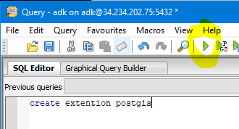Click on the Postgres database and then click the Query button 
6. In the query dialogue, type ‘create extension postgis’ and hit the Run button
7. Your database is now ready to populate

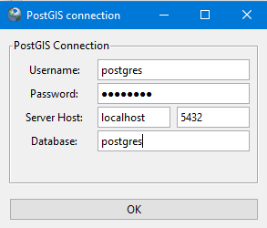Load a shapefile into the database

1. Open up the ‘PostGIS Shapefile Loader and Exporter’ to import some shapefiles into your database.
2. Click ‘View Connection Details and fill it in like shown on the right
3. Now Click on add file and navigate to shapefile on your hard drive and add it to the import list
4. 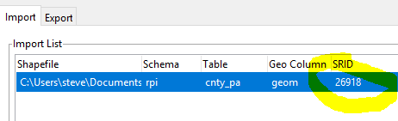Be sure to fill in the SRID column with the correct CRS # for the shapefile. If you don’t know it, look in the .prj file.

Connect to your database from QGIS

1. In QGIS, go to Layer🡪Add Layer🡪**Add PostGIS Layers** and click ‘New’
2. Fill in the dialogue as shown below, test connection and save.
3. Now you should be able to connect to your database from QGIS.

